Wedding Planning Packet
This Planning Packet is designed to collect and organize all your event’s important details.
If you have not hired a professional wedding planner, you will be responsible for updating this information and submitting it to us within a 1-month window of your event so that we can review and finalize it with you.
Your second deposit and final menu and beverage selections are also due 1-month prior to your event.
Your final head count is due the Monday the week before the week of your event.
Your important dates, amounts and submission/payment instructions are all located in the original contract email and/or the contract itself.
All important details about the venue such as floorplan diagrams, list of furniture and more are posted on the websites.
Please fill in all applicable information to the best of your ability in a different color and be sure to delete all examples given below.

Event Information

Couple’s first names with phone numbers:
Important contact name and phone number:
Day-of/on-site contact name and phone number:

Event date:
Venue:
Ceremony location, if on property, specify where:

Event Time:
(per your contract or if you need to change it, please get approval from your event sales manager)

Guest arrival time-

Ceremony time (time on the invitation)-

Reception time-

Are you adding a fourth hour?

Do you confirm that you have read and understand the City Noise Ordinance and accept risk if your event exceeds the time?

Ceremony Rehearsal Walk-through
We allow a 30-minute window for ceremony rehearsing. You will need to let us know what day you prefer. We cannot guarantee a time later than 4pm, all times must be approved and scheduled with your event sales manager based on the event schedule as priority. If you have a Sunday wedding, we do allow Saturday rehearsing between 10am-2pm, if approved by event sales manager.
In contracting with our venue, all clients agree and understand that there may be a rehearsal going on during a wedding or event set-up.

Rehearsal date and time:
(approved with event sales manager)

Pre-Event Set-up / Vendors
Your sales manager will be with you throughout your planning process to answer questions regarding the venue, your floorplan, food and beverage.
You will be assigned a day-of venue operations manager the Wednesday the week prior to the week of your event. This manager will be on property approximately 3-hours prior to your event to help receive your vendors, direct our staff for set-up and floorplan, oversee food and beverage hospitality, then throughout and post your event.
If you feel like you need more assistance, please consider hiring a professional day-of or month-out wedding planner.
All hired professionals/vendors are allowed a 3-hour window prior to your contract time to arrive at the venue and begin set-up, decorating, deliveries etc.
All items personal and/or otherwise must be removed from the venue within 1-hour after the event during breakdown/clean-up.
If you forego hiring a wedding planner, please assign a friend or family member to be responsible for all personal items getting properly in place prior to the event and removed post-event.
We recommend having a car ready at the end of the event for gifts and personal items.

Please include a list of your hired vendors, direct contact phone number and approximate load-in time below. Add any additional vendors not listed.

Wedding planner or day-of designated person:
Officiate (if ceremony is onsite):
Musicians or DJ for ceremony:
Photographer:
Videographer:
Florist:
Candles/Décor:
Bakery:
Band or DJ for reception:
Photobooth:
Transportation:
Rentals:

Event Timeline
Day-of/pre-event details:
We allow you and your wedding party to arrive no earlier than 1-hour prior to your guest arrival time or reception time (if no ceremony is taking place on-site). The Lakehouse does not have a holding area for wedding party. Maison Lafitte has a suite that is available within that 1-hour window. La Provence has 3 suites, that must be rented, if you do so, the check-in and check-out times and instructions will be on your room agreement.
All on-site, pre-event photography must be done within the 1-hour window, no exceptions. You can coordinate a pre-event timeline including photography details directly with your photographer or wedding planner.
Please include the following applicable information and any other details you believe are important:
- Where are you getting ready?
- Do you plan on arriving at the venue early? If so what time?
- Are you putting your dress/suits on at the venue?
- Will you be using the suite (only applicable to Maison Lafitte and La Provence)?
- If at La Provence, list the suites you are renting:
- Are you planning a “first look” with your photographer? If so, what time?
- Additional notes:

Ceremony
If your ceremony is located at our venue, please fill in the following information and include any other details you believe are important.
Please describe your rain plan; rain plan must be confirmed with your day-of event manager within 6-hours of your event (all tents must be rented and managed through a rental company)
- Option for Maison Lafitte – move ceremony under pavilion ($500 flip fee)
- Option for The Lakehouse Buy-Out– move ceremony to side courtyard and rent a tent ($500 flip fee)
- Option for The Inn at La Provence Buy-Out – 1. move ceremony indoors to Sterling Ballroom for up to 150 guests and ($500 flip fee) or 2. rent a tent and/or flooring for the Cypress Garden (no flip fee if reception takes place all indoors)

- Where on property is your ceremony located?
- What type of music will you have for your ceremony?
- What type of Décor will you provide?
- Do you have any need for a table at the altar? (example- lighting of a unity candle, sand ceremony, signing of marriage certificate)
- Additional notes:

No two wedding ceremonies are alike. Even if some couples say the same vows or take a deep dip for the kiss, every pair has a unique mix of things as it comes to their officiant, remarks, ring exchanges, recessional and more. That said, the below is a traditional wedding ceremony order of events to guide your preferences. We have used a timeframe starting with 0 o’clock to represent the timeframe in between each item on the timeline, please fill in your actual times in place of our examples.

00:00 Guest Arrive; this typically begins approximately 30 minutes prior to the time on your invitation, please reference your contract time. It is often nice to have music playing while guests choose their seats.

00:30 The Procession / Ceremony Begins
This is the part where the wedding party walks down the aisle and takes their places for the ceremony. You can each make your way to the altar separately, symbolizing the fact that you're coming from different backgrounds. Or in some cases, the couple will walk together to symbolize coming into the marriage together. In a Christian procession, the bride is escorted by her father, while the groom waits for her at the altar. In a Jewish procession, the groom's parents escort him down the aisle, and then the bride's parents escort her down the aisle. Feel free to customize this special part of your ceremony.
The Officiant's Opening Remarks
You've heard it a hundred times: "Dearly beloved, we are gathered here today..." Or some start by saying, "Friends and family..."
The Officiant Addresses the Couple
Your officiant may take this moment to emphasize the significance of the vows you're about to exchange. This may also include a reminder of your duties and roles in marriage.
The Exchange of Vows
Your vows are your promises to each other. You may repeat the familiar "to have and to hold, for better or for worse" vows, or recite ones you've written yourselves.
The Ring Exchange
As you exchange rings, you typically say, "With this ring, I thee wed."
The Pronouncement of Marriage
The officiant makes it official.
The Kiss
And now the moment everyone's been waiting for: your first kiss as a married couple.
The Closing Remarks
Your officiant wraps things up with a few last words and, for a religious wedding, a blessing.
The Recessional
Basically, the reverse of the processional, you exit the ceremony together as newlyweds, followed by the wedding party.

Reception
The vital thing to hosting a stress-free and memorable wedding celebration is knowing what is supposed to happen next and when. Here is a handy guide to help you plan your wedding reception timeline, based on a traditional Southern 3-hour Reception. Keep in mind, we like to refer to these timelines more as “guidelines” as they “guide” us through the evening keeping us on task, but also allowing the flexibility and versatility crucial to you and your guests having a great time.

01:00 Reception Begins
If your ceremony takes place on the same property as your reception venue, the reception will start immediately following the recessional.

01:00 | The Cocktail “half-hour”
After being pronounced a married couple, you're often the first to leave the wedding ceremony, heading off (with photographer in tow) for pictures together before the partying gets under way. Your guests will head to the reception site for cocktails. Depending on the logistics of the event, your cocktail time will begin immediately (if the ceremony and reception are held at the same venue), or it might start more than half an hour later (if there's travel involved). Cocktails will kick off your reception and will last for at least a half hour. During this time, the staff will serve stationary and passed appetizers and drinks, which will get people mingling and in the mood for fum. If your reception is starting later than 730pm, we recommend foregoing a traditional cocktail time and serving all food right away, no one wants to be “hangry”.

01:20 | Newlyweds' Sweetheart Meal
If you are hosting a large reception, you may consider sneaking off as a newly married couple to enjoy a quiet meal together prior to being announced and after your post-ceremony pictures are complete. This is a great time to take a breather, use the restroom, bustle your dress, or sign marriage certificates because once you enter your reception you may never get a chance to sit down for the rest of the night. It is also a great photo op! We will make sure to keep this meal short and sweet so you can get down to all the action and your eager guests.

01:30 | Newlyweds' Arrival/First Dance
Here's the part where you make your grand entrance. Traditionally, both sets of parents and the wedding party are introduced, followed by the announcement of you both for the first time as a married couple. But we often see a simplified version of this, just announcing the couple. Please indicate to us what you decide and coordinate directly with your DJ/Band. In many cases, your newlywed first dance will begin as you step out onto the floor and into the spotlight after being announced, followed by the father/daughter and mother/son dances or whichever type of formal dances you may have planned. We typically open the buffets at this time, so that guests can begin eating immediately following. We recommend that the DJ/Band do not make a formal announcement that food is being served.

01:40 | Cheers & Toasts & Dining!
Following your first dance, you might want to take the opportunity—while all eyes are still on you, since hopefully no one yet has had too much to drink—to thank everyone en masse for taking part in your wedding. A family member, often a parent of the bride, will say a blessing (depending on the families' faiths). This step is completely optional since traditionally, in the south, all important speeches and toasts are given at the rehearsal dinner in a smaller more intimate setting.
If you have decided to open your buffets after the announcement, your guests will now be eating for 30mins to 1-hour. Some couples prefer to knock out all the items on their timeline early so that they can enjoy the evening less interrupted. On that note, some couples choose to cut the cake immediately following the first dances, while still looking fresh, for those pictures. We can wait to serve the cake. This is also a good alternative plan for couples who do not mind not having all eyes on them for the cake-cutting. Please make sure to indicate your preference.

02:40 | Cake Cutting
More traditionally, the cake cutting will happen about an hour after guests have begun eating. We take the cake to the back kitchen to cut and then tray pass serve to all your guests. Guests may have started dancing already.

03:00 | Party Time
Throughout the dancing, the music will stop for any extracurricular activities you've planned (also known as the bouquet toss, the garter toss, money dance, bridal party dance, and whatever else you've dreamed up).
03:30 | Garter & Bouquet Toss
(please list all activities and approximate times)

03:50 | Last Dance
End your wedding on a high note and choose a dance song that will leave a lasting impression. You'll want everyone to have a chance for one last twirl, so select something fast and festive. The Band/DJ can also announce things like last call, sparkler send-off, and post-reception plans, some of our guests love to continue the fun down the street at Barley Oak.

04:00 | Final Farewell
Now it's time to say goodbye. Your venue event manager will usher everyone into the front or onto the steps outdoors so that as you make your grand exit from the reception, friends and family can blow bubbles, light sparklers, or toss rose petals—and cheer to your successful celebration and future together. We do allow sparklers. We do not allow confetti of any kind. Will you be getting into a farewell vehicle?

Please fill in the following information and include any other details you believe are important:
- Are you using the bubbly cart or have a welcome champagne station? (have you booked two events with us, this is one of the added upgrades if so)
- Do you prefer all food served immediately as the reception starts or do you prefer to wait until the newlyweds are announced onto the dance floor, the more traditional options? (if your reception begins later than 730pm, we recommend serving all food immediately as the reception begins)
- Please list all dances you have scheduled, such as the Father / Daughter dance, etc:
- Do you prefer to cut the cake immediately following the first dances or do you plan to wait until guests have eaten, the more traditional option?
- Do you have a wedding cake? If not, what do you have (Example- cupcakes)?
- Do you plan on keeping the top layer of cake to freeze? (We recommend that you bring in a Tupperware or have your baker provide the proper size box for us to pack up for you. We also ask the you to have the baker bring an extra box for leftover cake to go home in.)
- Do you have cake pulls? (for larger receptions, we highly recommend that cake pulls be done at smaller more intimate events, such as the bridal shower or luncheon)
- Do you have a groom’s cake or anything like it? (Example – donut bar)
- Do you have a guest book or anything like it? (Example- portrait for guests to sign, coffee book, or photo album)
- Do you have favors? If so, please let us know what they are and how you want them displayed or distributed?
- Please provide a list of all items you will be bringing in and any details concerning these items (Example- cake knife set, special champagne flutes to be placed on cake table). We remind you that you must designate or hire a person to be responsible for dropping these items off to us, setting them up, and then removing them. We recommend coordinating with your venue event manager, who will be scheduled 1 week prior to your event, a drop-off time that works for you and them. We do our best to be flexible, otherwise we allow your day-of person to come within the 3-hour window. We remind you that all items must be removed from the venue the same night of the event and that we are not liable for any such items left behind.
- Additional Notes:

Processional Order
We have included a helpful visual diagram below. Please fill in or create your processional order with the names your bridal party.

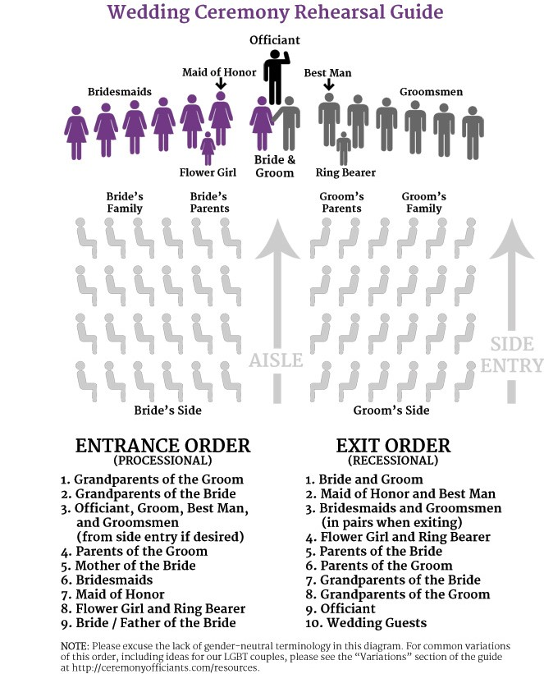

Grandparents of the Groom:
Grandparents of the Bride:
Officiant, Groom:
Parents of the Groom:
Mother of the Bride:
Bridesmaids/Groomsmen:
(in order, paired together or let us know if your bridesmaids will not be escorted by groomsmen, in that case they will walk out together with groom, please keep in mind that the best man and maid of honor will walk last)
Flower Girl/Ringbearer:
Bride / Father of the Bride:

Floorplan Notes:
Our floorplans are located on our websites. They are designed based on the best flow of the space for an event of your size and type. These have been developed over many years of experience in hosting events. Please select a floorplan, if applicable. If you have any comments or requested changes, please include below so we can address these with you.
(Example- I would like to use the entry table for my guest book and picture frames of our engagement portraits. The florist will also place an arrangement here. OR I prefer the groom’s cake in the front parlor, do you recommend this?)
- Include any information regarding a rain plan.
- Let us know the configuration of the Maison Lafitte pavilion panels if different from our standard configuration which is the back L-shape solid panels are down and closed and the front L-shape windowed panels are up and open.
- Will you need any of the climate control amenities we include? If so, please list.
- Will you be renting any additional climate control items?
- Will you be renting any additional tables, chairs, linens, etc? If so, please include a detailed list below (all items must be removed from the venue the night of the event).

